**Day 6 - Deployment Preparation and Staging/Environment Setup**

**Deployment Details:**

1. **Choose a Hosting Platform**
   * **Platform Chosen:** Vercel
   * **Reason:** Vercel is selected due to its seamless integration with Next.js and its ease of use.
   * **Deployment Link:** https://hackthon-e-commerce-ayx3.vercel.app/
   * **Repository Link:** <https://github.com/waqar786m/Hackthon-E-Commerce>

**Step 1: Hosting Platform Setup**

1. **Choose a Hosting Platform**
   * **Platform Chosen:** Vercel (due to integration with Next.js).
2. **Link Your GitHub Repository**
   * **Steps:**
     1. Log in to your Vercel account (or create a new account if necessary).
     2. Click on the "Add New..." button and select "Project".
     3. **Import GitHub Repository**:
        + Authorize Vercel to access your GitHub account, if prompted.
        + Select the repository you wish to deploy.

**Step 2: Configure Environment Variables**

1. **Add Environment Variables in Vercel**
   * **Steps:**
     1. Navigate to your Vercel project dashboard.
     2. Go to **Settings** > **Environment Variables**.
     3. Add the necessary environment variables one by one.
        + Example:

**NEXT_PUBLIC_SANITY_PROJECT_ID=your_project_id**

**NEXT_PUBLIC_SANITY_DATASET=production**

**API_BASE_URL=https://api.example.com**

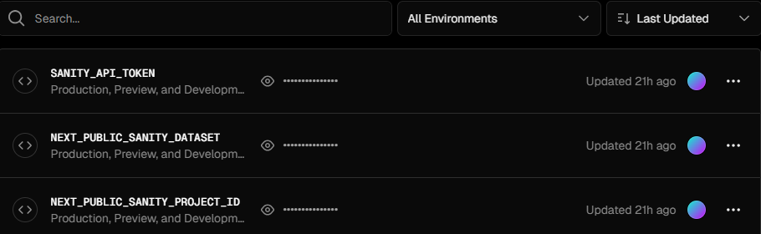

**Step 3: Test Staging Deployment**

1. **Deploy the Staging Branch**
   * Deploy the staging branch to the staging environment.
   * Perform all required testing (functional, performance, and responsiveness).
2. **Promote Changes to Production**
   * If the staging deployment is successful, merge the staging branch into the main branch to promote the changes to production.

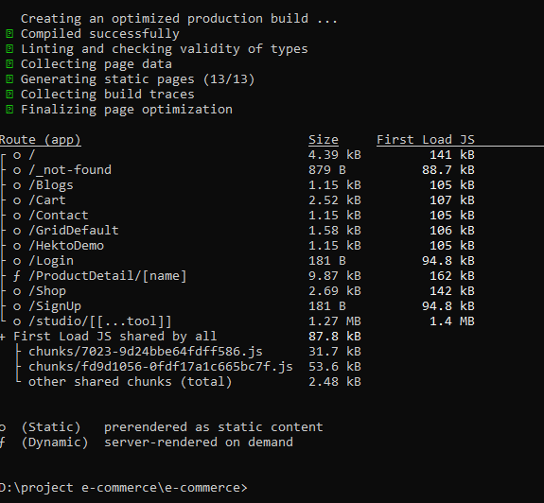

**Performance Checking:**

